

EQUIP ICE

ANGLÈS EN LA FORMACIÓ PROFESSIONAL

CODI: 0000240020 EQUIP ICE 16\_17

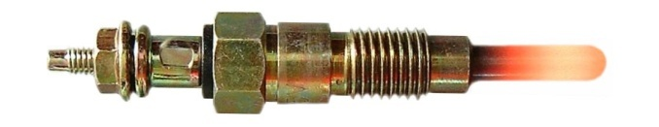

**Unit 1: The starting system in Diesel engines**

**STUDENT’S BOOK**

**Autor del material AICLE:**

Albert Panadés i Tocino

E-mail: apanade4@xtec.cat

Col·legi La Salle Mollerussa

**Integrants Equip ICE:**

Marc Huguet Caufapé

Ignasi López Piñol

Joan Carles Ballesté Coma

M. Montserrat Guasch Huguet

Núria Montserrat Farré Barril

M. Mercè Aldavert Fàbregas

Albert Panadés i Tocino



Els textos i gràfics publicats en aquests materials estan subjectes a una llicència Creative Commons. La llicència completa es pot consultar a http://creativecommons.org/licenses/by-nc-sa/4.0/

**Amb el suport de:**

**Curricular context:**

***MP02\_TM10Engine Auxiliary Systems. The starting system in Diesel engines.***

**Família de Transport i Manteniment de Vehicles.**

**Cicle Formatiu de Grau Mitjàd’Electromecànica de VehiclesAutomòbils. TM10**

**Mòdul Professional 02: SistemesAuxiliars del Motor.**

**Unitat Formativa 3: Verificació dels sistemes auxiliars.**

**Unitat Formativa 4: Diagnosi i manteniment dels sistemes auxiliars**

**Unit 1: The starting system in Diesel engines (timing 5h)**

* 1. *Checking Vocabulary*
  2. *Introducing vocabulary*
  3. *The wiring diagram*
  4. *Working with the car*

**Introduction:**

The starting system is an essential part of the Diesel engine so as to assist the engine in the first steps of working when the cooling system has a low temperature.

For this reason, the engine has an electrical system equipped with a relay and the glow plugs which heat the air of the combustion chamber and make the combustion easier.

In the following activities we are going to understand how the starting system works, build a wiring system in a panel and work with the system in a car.

**Objectives:**

–Learn to verify the heating system, checking their functionality.

–Select properly technical documents and useful instruments.

– Incorporate the use of English in professional situations and use the correct terminology based on transport and automotive maintenance

**Keywords:**

Diesel wiring diagram glow plugs

|  |
| --- |
| ***MP02Engine Auxiliary Systems.***  **Unit 1: The starting system in Diesel Engines** |

**ACTIVITY 1. Checking vocabulary.**

**Introduction.**

* Before learning about how the Diesel Engine starts, we are going to remember some vocabulary you learnt last year.

**At the end of this activity you can:**

* Remember different tools and parts of the car
* Remember the name of electrical parts of the engine.

**Activity 1.1. Remembering actions.**

There are some actions that we can use when we are repairing or fixing a car.

In this activity we are going to match actions with pictures.

Some actions could fit more than once.

Actions: *To check, to measure, to cut a wire, to remove, to tighten, to connect, to fit*

|  |  |
| --- | --- |
| TO MEASURE.JPG | TO TIGHTEN2.jpg |
| (1) | (1) |
| TO REMOVE2.jpg | TO ADJUST2.jpg |
| (1) | (1) |
| TO CUT.JPG | TO FIT2.jpg |
| (1) | (1) |

**Activity 1.2. Remembering car parts and tools.**

Label each picture with the following parts, tools and objects that we can find in a car. Some letters are given.

|  |  |  |
| --- | --- | --- |
| Torque wrench, battery, electrician scissors, wire cutter, multimeter, fuse, fuse holder, battery terminal, terminal | | |
| battery.png | TERMINAL.JPG | battery terminal.jpg |
| B\_ \_ T\_ \_ \_ | T\_ \_M\_ \_ \_L |  |
| FUSE HOLDER.JPG | fuse.jpg | torque wrench.jpg |
| F\_ \_E H\_ \_ \_ \_ R |  | T\_ \_ Q \_ \_ W\_ \_ \_ \_ \_ H |
| SCISSORS.JPG | multimeter.jpg | pliers.png |
| E\_ \_ \_ \_TR\_ \_ \_N  S\_ \_ S\_ \_ RS | M\_ \_ \_ \_ \_ \_ \_ \_ R | \_ \_ R \_ C\_ \_ \_ \_ \_ |

**ACTIVITY 2. Introducing vocabulary.**

**Introduction.**

* After remembering the vocabulary, we you are going to learn how the starting diesel engine system works. Before that, we must learn some vocabulary related to it.

**At the end of this activity you can:**

* Understand why this system is necessary
* Understand how the system works.
* Which is the method of operation of the system.
* Which parts belong to the system

**Activity 2.1. Parts of the starting system**

Match the word to the correct picture:

***Tip:*** Don’t worry if you do not understand the word clearly. Let’s do it!

|  |  |  |
| --- | --- | --- |
| Combustion chamber |  | GLOW_PLUG.jpg |
| Ignition key |  | Ricardo_comet_combustion.gif |
| Starter motor |  | ignition key.jpg |
| Pre-heating timer relay |  | Automobile_starter.JPG |
| Glow plug |  | RELAY.JPG |
| Indicator lamp |  | indicator lamp.jpg |

**Activity 2.2. How does the system work?**

Finally, we are going to read a text related to the starting system in Diesel engines.

First of all, you must remember how a Diesel engine works, so check out the last unit.

Some words are underlined and related to the pictures on the left.

Read carefully and underline if you do not understand some word. You can use a dictionary.

***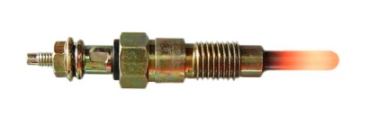Introduction. Why?***

*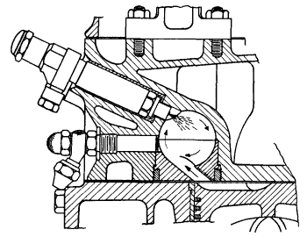When the engine is cold, the temperature inside the chamber is low, too. Although the piston rises and increases the air temperature, that is not enough to ignite the fuel mist.*

*For this reason, the air inside the chamber needs to be heated. A glow plug is activated temporary in order to heat the air. There is one glow plug per cylinder and is activated by a relay.*

*The system works in three stages:*

***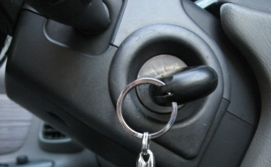Pre-heating***

*The driver turned the key to the "on" position for a long duration; the glowplug relay switches the glowplugs on, and an indicator lamp illuminates. This process is called "pre-heating". This process is used around a 6 to 8 second heat period*

***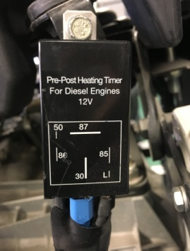Starting***

*When a pre-set time has elapsed, the glowplug relay switches off the indicator lamp. The driver then proceeds to turn the key to the "start" position. The relay switches on the glowplugs alternatively while the engine is running.*

***After starting***

*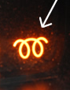In some cars, glow plugs continue to operate for up to 180 seconds after engine start to keep the engine within emissions regulations.*

**Activity 2.3. Understanding the system**

After reading the text, answer the following questions. You do not need to write a whole sentence.

1. How many stages does need the system to work? Write all of them.
2. How is the air temperature inside the *combustion chamber* when the engine is cold, *high* or *low*?
3. At which stage does the relay switch on the indicator lamp?
4. How are the *glow-plugs* working when the *starter engine* is running?
5. When the engine is running and it is hot, the *indicator lamp* is switched on from 6 to 8 seconds. True or false.
6. The glow plug heats the air inside the combustion chamber. True or false.
7. Before starting, the air is heated from 6 to 8 seconds. True or false.

**ACTIVITY 3. Wiring diagram.**

**Introduction.**

* After introducing the vocabulary to the students, we you are going to build the electrical wiring system of the starting diesel engine system.

**At the end of this activity you can:**

* Build a wiring electrical system.
* Understand how the system works.
* Check the electrical system and its parts.
* Measure different values

**Activity 3.1. Parts of the wiring diagram system**

In a wiring diagram there are some elements that we need to know. Draw the picture or symbol and associate it with the name in the following boxes.

|  |  |  |
| --- | --- | --- |
| *Power supply BAT, power supply ACC, ground GND, fuse, switch, push button, relay, resistor, power supply starter, indicator lamp* | | |
|  |  |  |
|  |  |  |
|  |  |  |
|  |  |  |

**Activity 3.2. Construction of the wiring electrical system**

*Identify the parts*

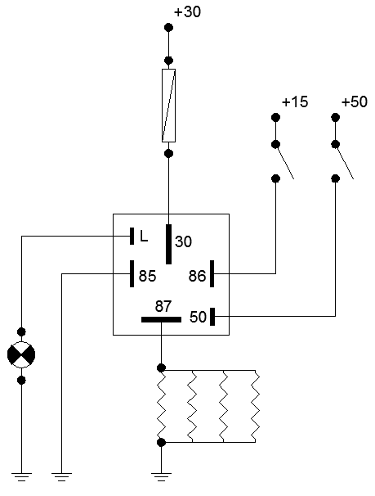First of of all, try to identify every part of this diagram using the previous learnt words.

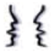

*Prepare some questions.*

Before designing the electrical system, you will need some parts. Ask your teacher for the parts that you need. Try to ask making some questions.

* *Can you give me a ……, please?*
* *Would you mind giving me a ………., please?*

*Build the wiring electrical system*

We are going to build a wiring electrical system. According to the following wiring diagram, build the system on a wood-board.

***PREVENTIVE MEASURES:***

* Be careful when you are using a cutter or a pair of scissors.
* Before plugging in the power supply, check all the connections, sockets, etc.
* Check the voltage in the power supply. 12 Volts maximum
* Ask the teacher to check the wiring circuit.
* Plug in the power supply and check how the system works.



**Activity 3.3. Assessment**

* How long does the indicator lamp switch on before the engine starts?
* When does the indicator lamp switch off?
* Before starting the engine
* During the starter-motor is working
* After starting the engine
* Complete the following statements:
* In the first stage the glow-plugs are……..
* In the …………… stage the glow-plugs are working during 3 o less seconds.
* The indicator lamp works before the ……………… is activated.
* The indicator lamp switches off when the ……………….is working.

**Activity 3.4. Working with the multimeter**

Make the following actions drawing the multimeter on the wiring diagram and writing down the value.



|  |  |  |  |
| --- | --- | --- | --- |
| **Part** | **Reference value** | **Real Value** | **👍/👎** |
| Check the positive connection. Power supply BAT |  |  |  |
| Check the positive connection. Power supply glow-plugs |  |  |  |
| Check the ground connection. Ground connection of the pre-heating timing relay. |  |  |  |
| Check the intensity of the glow-plugs |  |  |  |

**ACTIVITY 4. Working with the car.**

**Introduction.**

* After building an electrical wiring system, you are going to practise in a car. You will learn how the starting diesel engine system works inside the car.

**At the end of this activity you can:**

* Locate the main parts of the system on the car.
* Find on a database program the usual technical data.
* Check the electrical system and its parts
* Find out possible failures.
* Prepare a budget for a costumer.

**Activity 4.1. Vehicle identification of the car and possible failures**

First of all, you need to find vehicle identification and ask your customer for the possible fault or breakdown. Please, ask your teacher using the following questions given and write down your answers.

|  |  |
| --- | --- |
| **MAKE / BRAND (Ford, Renault, etc...)** |  |
| **MODEL** |  |
| **ENGINE** |  |
| **YEAR** |  |
| **VIN (vehicle identification number)** |  |
| **SYMPTOM or SIGN**  **(underline the symptom your costumer said)** | * Engine fails to rotate when attempting to start * Engine rotates but will not start * Engine difficult to start when is cold * Engine difficult to start when is hot |

***TIPS:***

* Would you mind telling me the about problem, please?.
* Which problem does the car have?
* What is the problem with the car, please?
* What is wrong with your car?
* Is it difficult to start your car?

**Activity 4.2. Analysing faults and finding possible solutions**

You are going to analyse the fault and find the possible solution. Please fill in the gaps from the following table with your own ideas. A simple is given.

|  |  |
| --- | --- |
| **SYMPTOM**  **(what the costumer said or propose)** | * ***Engine fails to rotate when attempting to start*** |
| **POSSIBLE CAUSES** | * ***Battery discharged*** |
| **PARTS OF THE SYSTEM RELATED**  **(remember the parts)** | * ***battery*** |
| **HOW TO PROCEED**  **(remember the actions)** | * ***Test the battery with a multimeter.*** |

**Activity 4.3. Checking the system**

After finding the possible causes, you are going to test the possible parts of the system that you believe are wrong.

You need to find on database software, the procedure and the reference value for an each testing.

In each part:

* Write down the part you are going to check
* Write down the reference value.
* Write down the real value.
* Match if it is *correct* or *wrong*.

|  |  |  |  |  |
| --- | --- | --- | --- | --- |
| **Part** | **Action** | **Reference value** | **Real Value** | **👍/👎** |
| BATTERY | Voltage. Between + and - | From 12.0 to 12.7V | 12.35V | Right |
|  |  |  |  |  |
|  |  |  |  |  |

**Activity 4.4. Conclusions.**

As a future technician you will have to explain to your customers which systems need to be repaired.

Now, you are going to speak with a partner/teacher about the inspection. There are two roles: as a *technician* and as a *customer*.

**Rules:**

The customer will pose two or three questions about:

* Which parts of the car have been checked?
* Which parts of the car have been replaced or refilled?

The technician will answer those questions using these expressions:

* I replace the………….….because……………………..
* First of all, we have ……………… the……………….... and the result was………….…

**Tips:**

***Possible tenses***

When you say a statement about the past, you need to use the past simple tense or the present perfect. Have a look at the following statements:

* I *tested* the battery and it *was* right. (yesterday)
* I *have* just *tested* the battery and it was right (just a few moment ago)

***Possible questions:***

You can use the following questions

* Which part of the car did you repair? I repaired.....
* Which part of the car did you test? I tested......

Write down your conversation and try to practise with your partner. Use the space below for writing your ideas. Prepare a guideline in order to help you better.

**Activity 4.4. Extra-.work. Challenge.**

*What can you do in 90 seconds?*

As final work, you are going to record a video with your mobile phone. You need to explain one of the following items in 90 seconds.

* Explain why the starting system in a Diesel engine is used.
* Choose one part of the system and explain how it works.
* Explain one failure and its possible symptoms.

After recording the video, upload it to YouTube and send the link to your teacher.

**References:**

* The main resources for the activities and a guide for the student is based on the book: SISTEMES AUXILIARS DEL MOTOR. José Pardiñas. Editorial Editex. ISBN-978-84-9003-289-3
* The wiring diagram has been originally made by me through Autocad 2015 Student License

I hereby declare that all pictures used in this work are original and labelled for reuse and non-commercial activity, and that the *wiring diagram* was created with educational and non-profit objectives and under the scope of the Autodesk Educational software license agreement.